Mobile Development Project A

Index Page

Contents
Description of the Program, how it Runs, what values to enter Mobile Development 2
How to Handle Error in a program 8
The Version of program used. 8

Description of the Program, how it Runs, what values to enter Mobile Development
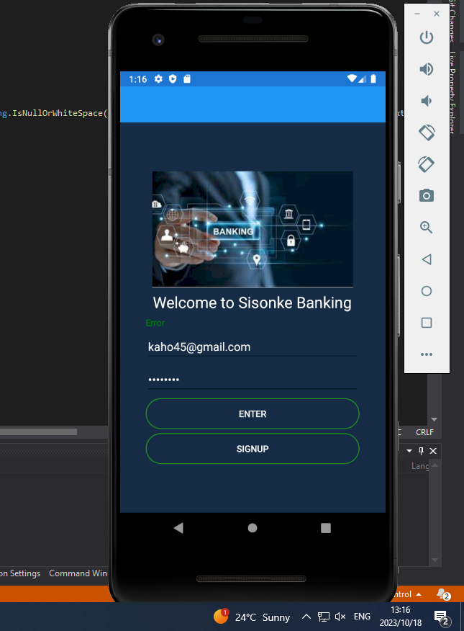

A Description of the Login Page program
Sisonke bank is a new and emerging bank in South Africa. We were tasked to create a program using Mobile Development, the programs consist of a loginPage, MainPage, Registration Page, and a transferPage.The user will be greeted with the loginPage, when you see the loginPage you are seen as a new user in the program.Click on SignUp and it will redirect you to the.

A Description of the Registration Page Program
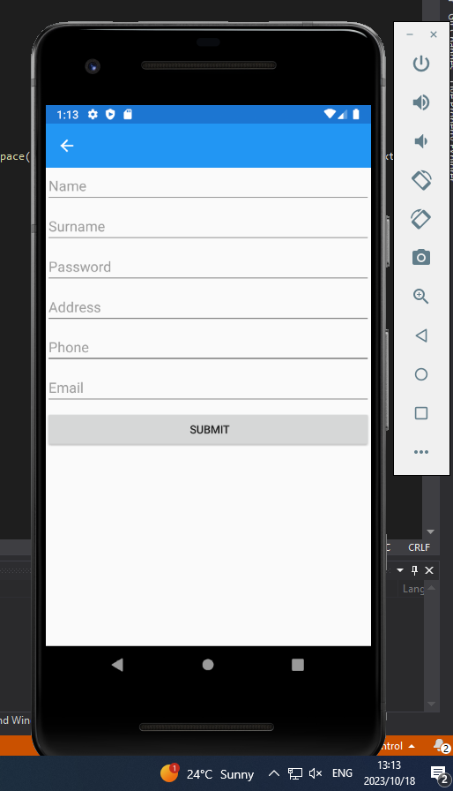

Once the user greeted is with the RegistrationPage the user will have to input their information into the program, they must fill in all the empty fields. When the user I s done, he/she should enter Submit.

Information Inserted Successfully

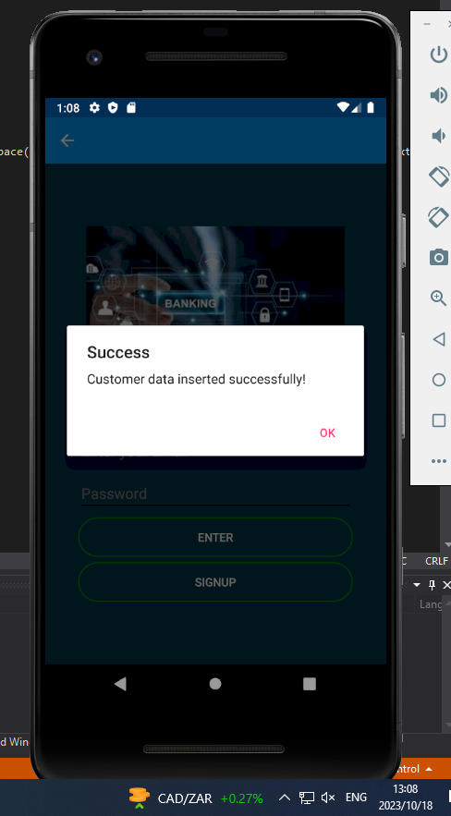
After Submitting the application should send you a messages that says Customer data inserted Successfully as stated in the above picture.

A Description of the MainPage of the program.
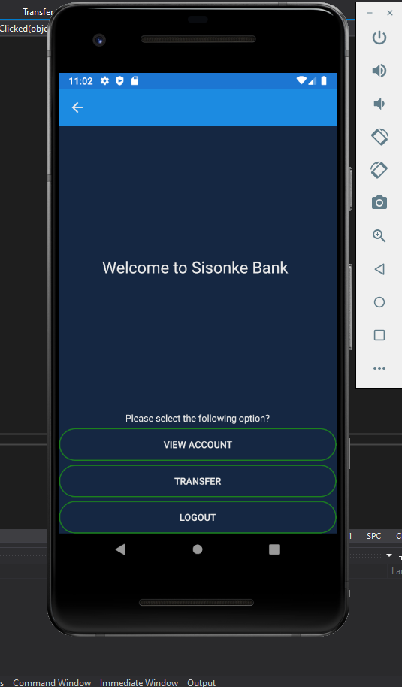
Once the user has inserted the information successfully, he will be greeted with the the MainPage of the program.The Page consists of a View Account,Transfer,Logout, if the user clicks on the button it will redirect to the specific place.

A Description of the View of the program in Mobile Development
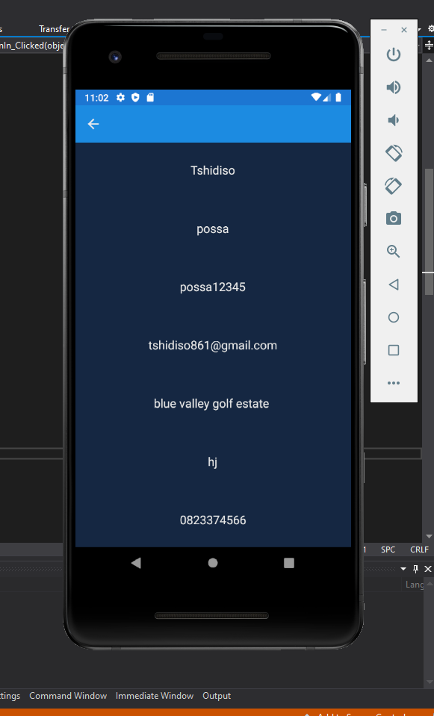

The View Account will display the user information that he/she used to enter in the
Registration Page. It captures the information from the Registration Page and displays it here.

A Description of the Transfer of the program in Mobile Development

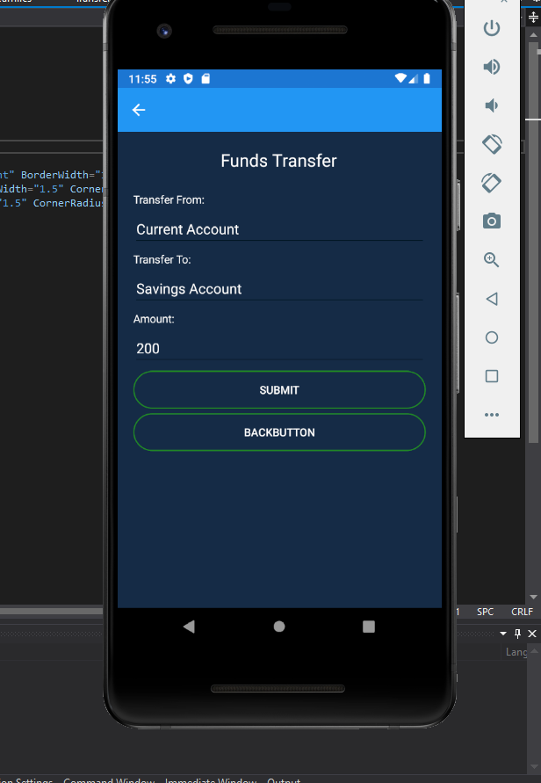
If the user selected Transfer the user will be able to make a transfer to the different account. To use the transfer the page the user will need to select the account which is current account and transfer to they must select to as Savings Account and under that enter an amount. Click on submit and it will transfer.

How to Handle Error in a program

How should a user handle error in a program? To catch a error message a user should user a function called try and catch……
With a try and catch the user must enter information in the try like what they want to try out and run the app. Whatever ever error you get you should now enter it into the catch code, from there the code will catch all the errors in the program.

The Version of program used.
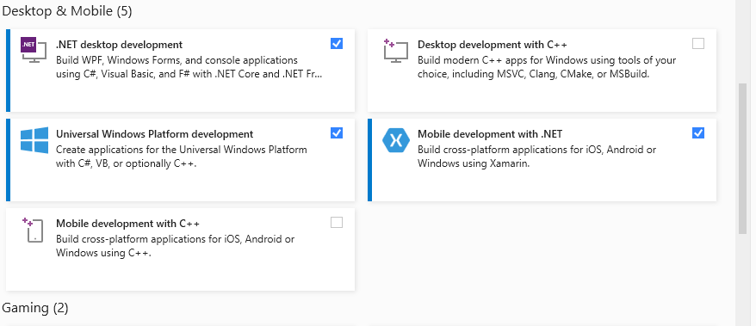

The Program used is Visual Studios 2019 and the version used is Mobile Development with Net.
It helps the user access mobile development features such as Xamarin and other features

The Program used is Visual Studios 2019 and the version

How to install and set up the app and which operation system to use

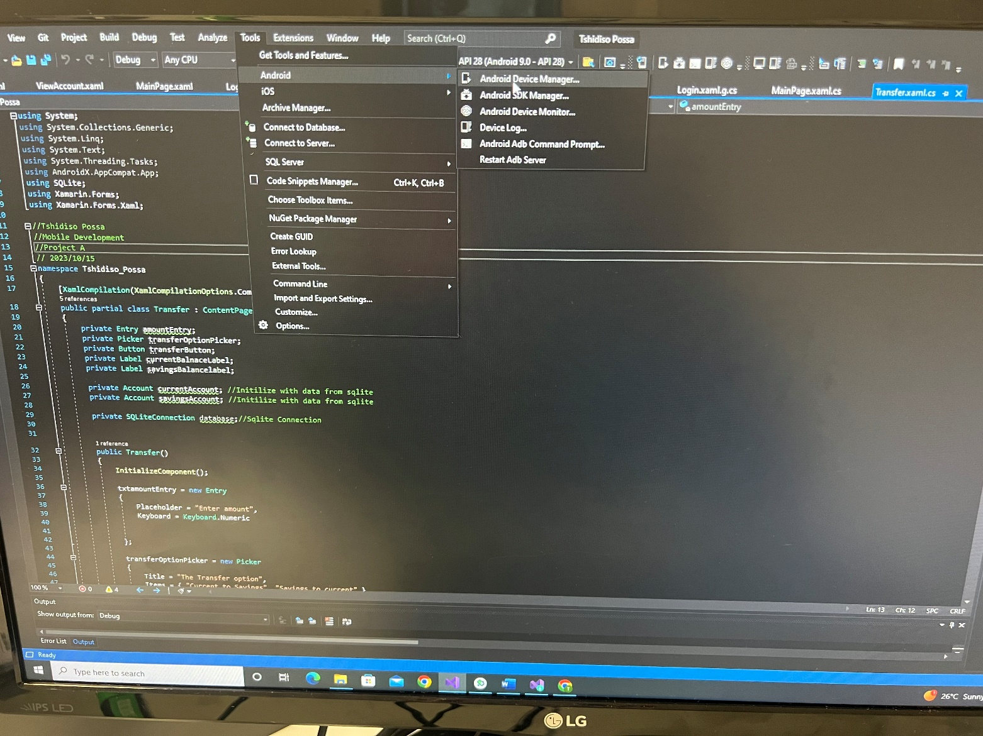

To install and set up the app the user should enter their program. In the tool tab on top of the page click on it and selected Android.After selecting Android Select “Android Device Manager”.

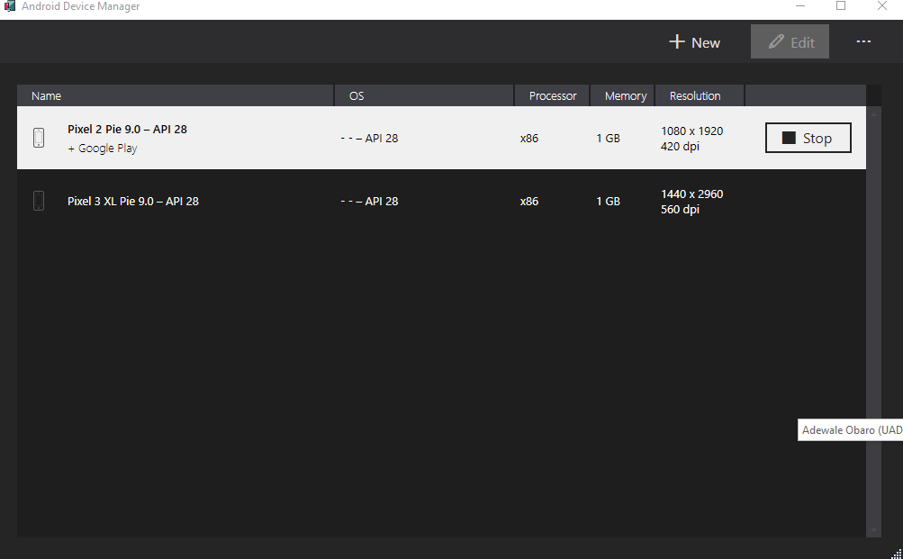

Once the user has selected “Android Device Manger” the user will then be greeted with this page. If you see this page because you are new user. Select “New” and you will be able to create your own android Emulator.
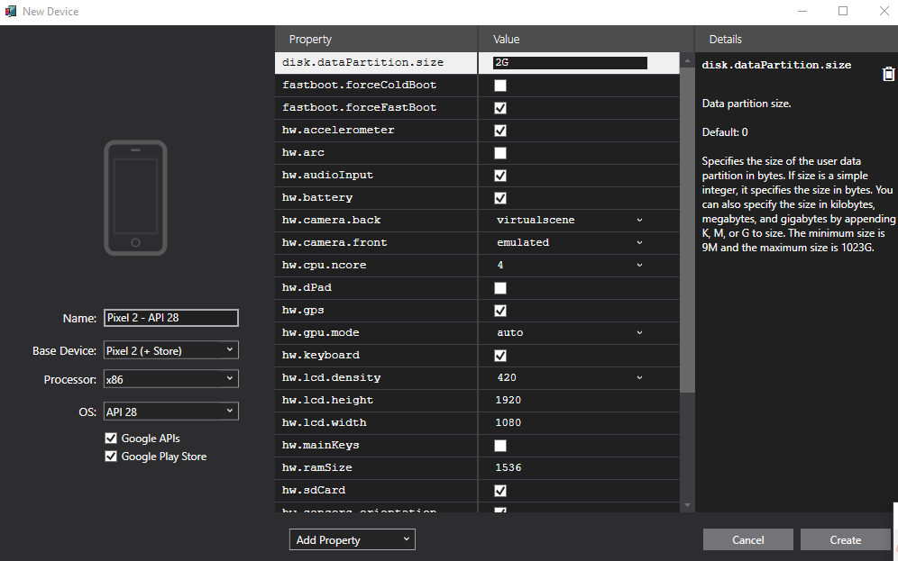
Create your own Emulator and select Create when you done. After pressing click it will start downloading

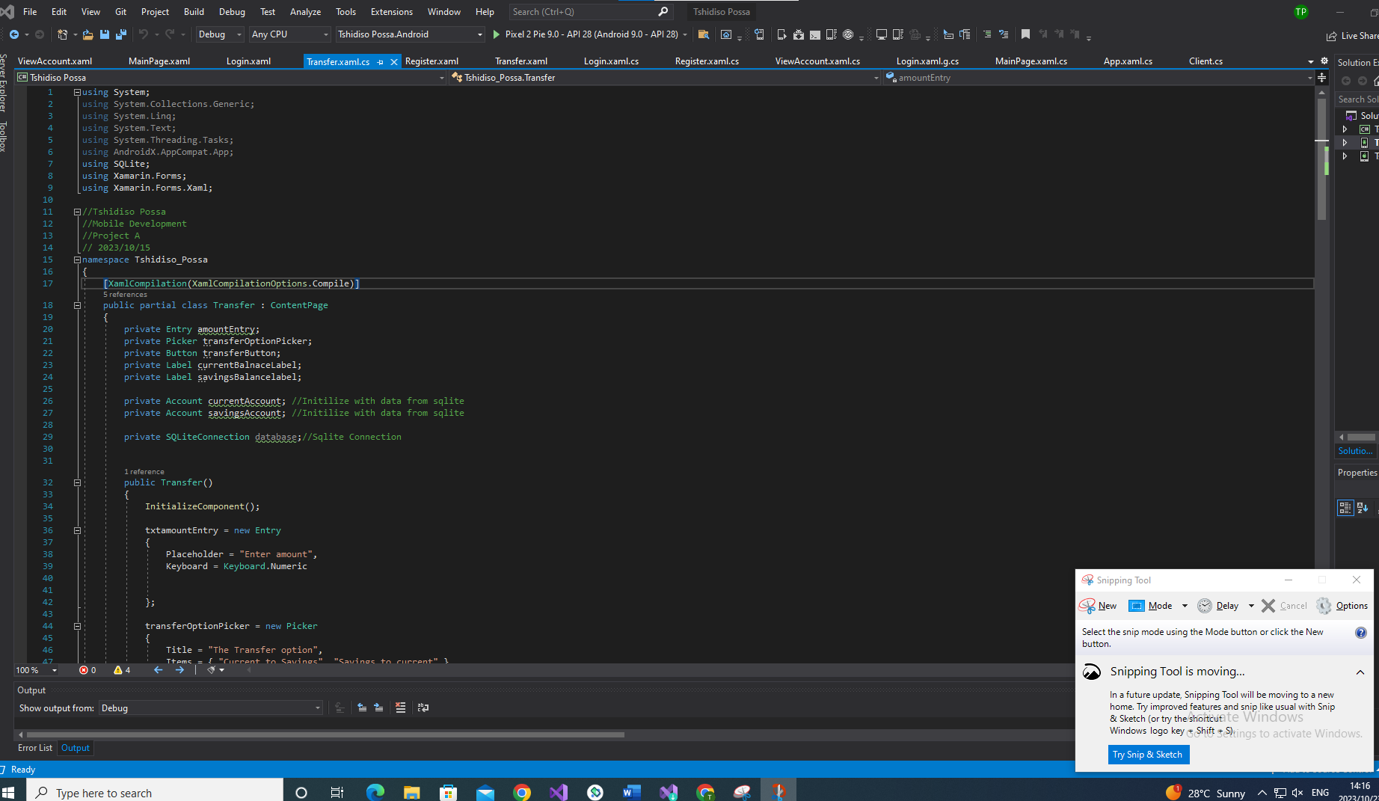

After Downloading on the green Triangle, you will see your Emulator “Pixel 2 pie…….”

